Waggle Dance Relay
At Home Activity

Bees in a colony work with each other to gather food and try to find the most pollen and nectar in the least amount of time possible. Bees communicate messages to other bees about where pollen and nectar are through a waggle dance. The dance is used to get other bees to help collect resources for the hive.

We are going to do a human version of the waggle dance to decode messages. You will need a friend to do this activity with. Decide who will be the first worker bee. The worker bee will open one of the messages. That bee must communicate the message to the rest of the group using the waggle dance moves. You are not allowed to speak to one another.

The others must correctly translate the message verbally. Then they must correctly dance the message back to the worker bee. Take turns as the worker bee, and communicate messages back and forth. Tally how many correct translations each person completes.

Before you start, it is recommended that as a class you practice the moves all to familiarize before starting the game. If you get stuck, you can try translating one line at a time. You can also shorten the messages from 8 lines to 5 lines.

Try making your own messages to translate. B sure to share your waggle dance with us!
@pharmabees

Waggle Dance Moves:

- Spin clockwise = turn right
- Spin anti clockwise = turn left
- Walk in place = go forward (each step is forward one)
- Jump = go up
- Crouch = go down
- Criss-cross = turn around
- Hands in the air = reverse (each wave is back one)
- Jumping jack = back to the hive

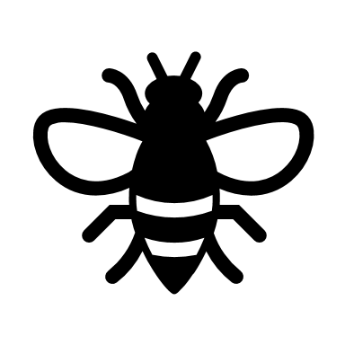
Waggle Dance Messages

go forward 5
turn right
go forward 3
go up
turn around
go back 2
turn left
back to the hive

turn left
go forward 6
turn right
go down
turn around
reverse 2
go forward 2
back to hive

go forward 4
go down
go forward 2
turn left
reverse 3
turn right
turn around
back to the hive

turn around
reverse 5
go up
go forward 6
turn right
go down
turn right
back to hive

reverse 8
turn left
go up
turn right
go forward 3
turn around
go forward 4
back to hive

go up
go forward 7
turn around
go down
reverse 3
turn left
go forward 4
back to hive

go forward 6
turn right
go down
turn right
go forward 8
turn around
go forward 4
back to hive

reverse 3
turn around
go forward 5
go up
reverse 2
turn around
reverse 6
back to hive

turn right
reverse 5
go down
turn left
go up
go forward 5
turn around
back to hive

go forward 7
turn around
go up
turn left
reverse 5
turn right
go forward 4
back to hive

