Teacher Resources
Session 2

In Class Activities

Activity 1: Bacteria Swab
Rules for working with bacteria:
- Never eat or drink near your cultures, be sure to wash your hands after working with cultures at the end of class.
- Keep the lids on your cultures and remove only briefly as needed.
- Wash your hands immediately after working with bacterial cultures.
- Sanitie the work surface you are using before and after working with bacteria.
- When you have finished with your cultures, clean the container well, and throw away the potato slice. An easy way to clean is to pour in a little bleach into the container with the potato to kill all bacteria, dispose of the potato, and then clean the container.
Potato preparation:
Supplies:
- Potatoes
- Knife
- Cutting board
- Clear container

Prepare the potato to grow the bacteria on. Carefully clean one or two large potatoes. Boil potato for 10 mins to sterilise the potato. While the potato is boiling, get a clear lunch container or jar, and clean. Sanitise the container with boiling water. Also sanitise the knife and cutting board with boiling water. After the potato has boiled, drain and let cool. Slice the potato in 1cm slices and place into container. Keep container sealed until the swabbing activity.
If there are enough containers for each student, place one potato slice in each container. Otherwise, split the class into groups, and place those slices into the container (For example a group of 6 would have 6 slices in a container). The slices should lay flat and not be stacked. The lid should be clear so that students can see the bacteria growth on the potato slice without opening the container.

Bacteria Swab:
Supplies:
- Cotton buds
- Potato slices
- Container
- Marker for labelling

Each student should have a potato slice and cotton bud. Have students think of an item or area in the classroom they would like to swab. Make a hypothesis regarding which item/area will have the most bacteria. Hand out the cotton buds to each student and explain the importance of starting with a sterile cotton bud. Have students swab the item/area and then immediately swab their potato slice that is in the container. Close the container immediately after swabbing. Let the containers incubate in a warm, dark place. Check growth after 24 hours. Some bacteria may have started growing. Check again in 48 hours and compare the difference. You should see bacterial growth within a few days.
On a map of the classroom, plot the results of where the bacteria are growing. Which spots in the classroom have a lot of germs? Discuss why some spots may have more bacteria then others, and the importance of sanitation.
Optional: Make a hypothesis about which place will be best for growing bacteria. Place some containers in the light (such as by a window), some in a cool area (such as a refrigerator), some in a warm area (by the heater), and some in the dark (such as a closed drawer). Check the growth from all areas each day and compare results.

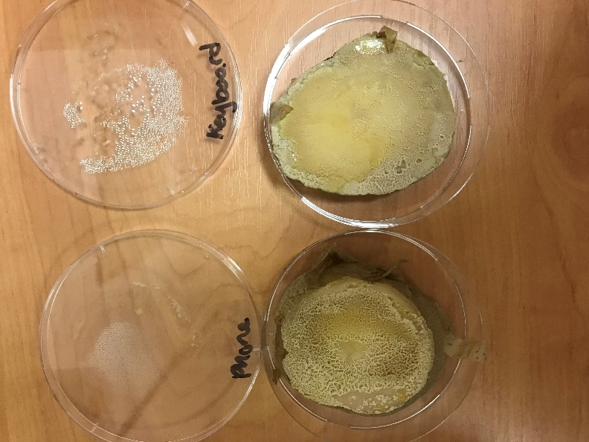
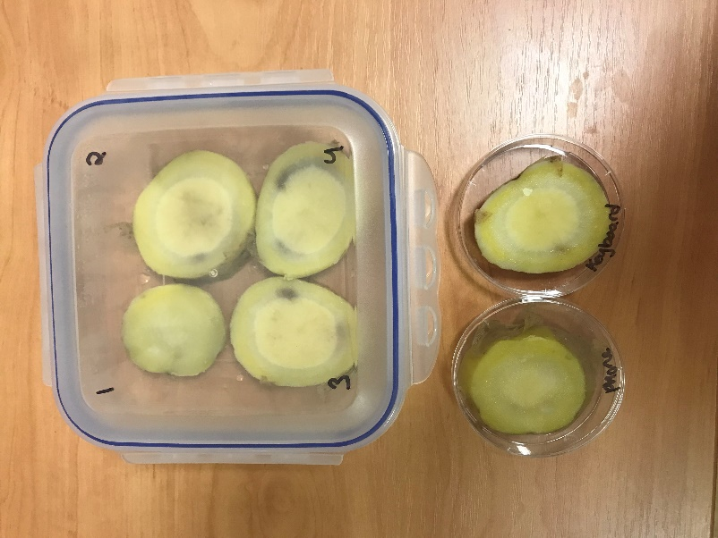

Prepared potaotes before swabbing Potatoes after 48 after swabbing

Activity 2: Transmission
Supplies:
- Glitter in different colors
- Timer
- Bowls
- Sink
- Soap

Put a small amount of glitter in a bowl. Each color of glitter should have its own bowl. Assign the different colors to disease, such as red for the flue, or blue for a cold. Have students dip their hands into the one of bowls of glitter and rub their hands in the glitter. Their should be glitter stuck to their hands. Have students walk around the classroom for 2 minutes shaking hands with other students. After 3 minutes, check to see where the glitter spread, and what colors/disease each student has. Check if students touched their face, and discuss how germs enter the body. Where in the classroom can you see the glitter? Check desk tops and door handles. Germs and glitter both spread very easily. Discuss how quickly germs can spread from one person to another. It only takes one person not washing their hands to infect a room full of people. Have students wash their hands after the activity. Discuss how soap helps water wash the germs away and that’s why it’s important to use soap every time you wash your hands.

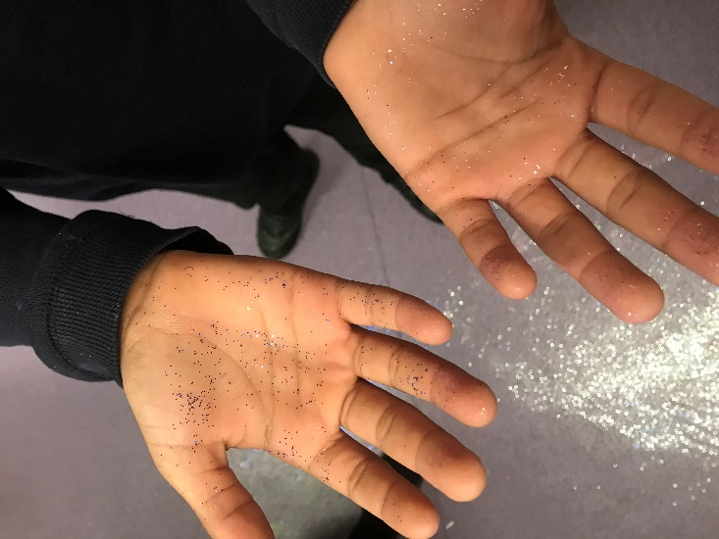

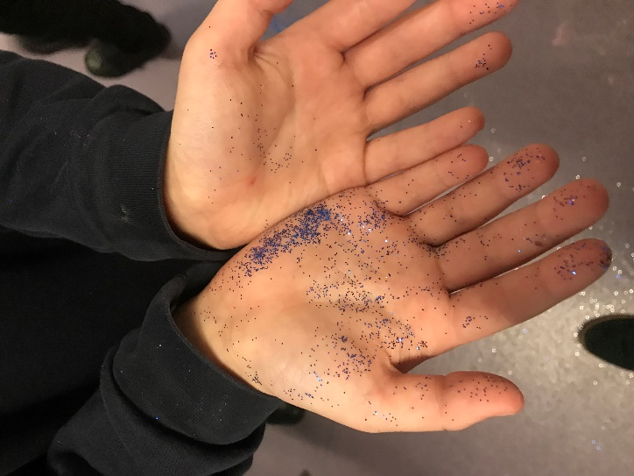

Sources & Resources

Bacteria Overview:
https://microbiologyonline.org/about-microbiology/introducing-microbes/bacteria
https://www.natgeokids.com/uk/primary-resource/bacteria-primary-resource/

Microorganisms:
https://www.bbc.co.uk/bitesize/topics/zfxxsbk

Food Poisoning and how bacteria grow:
https://www.safefood.eu/Food-safety/Food-Poisoning.aspx

How long can bacteria and viruses live outside the body:
https://www.nhs.uk/common-health-questions/infections/how-long-do-bacteria-and-viruses-live-outside-the-body/

Different types of germs:
https://askabiologist.asu.edu/explore/puzzling-pathogens

What is an Antibiotic and how they work:
https://learn.genetics.utah.edu/content/microbiome/antibiotics/
https://microbiologysociety.org/education-outreach/antibiotics-unearthed/antibiotics-and-antibiotic-resistance/what-are-antibiotics-and-how-do-they-work.html

Antibiotic Resistance:
https://www.who.int/news-room/fact-sheets/detail/antibiotic-resistance
https://www.khanacademy.org/science/health-and-medicine/current-issues-in-health-and-medicine/antibiotics-and-antibiotic-resistance/a/what-is-antibiotic-resistance

Calculate how quickly bacteria can grow:
https://www.bbc.co.uk/bitesize/guides/z243g82/revision/2

Vaccine Information:
https://www.nhs.uk/conditions/vaccinations/nhs-vaccinations-and-when-to-have-them/
https://www.nhs.uk/conditions/vaccinations/why-vaccination-is-safe-and-important/

Brief Video Introduction to Microbiolgy:
https://www.youtube.com/watch?v=WlGQaVgfpmw&t=82s

The Plague Overview:
https://www.bbc.co.uk/bitesize/guides/z7r7hyc/revision/1

Importance of Handwashing:
https://www.cdc.gov/handwashing/why-handwashing.html
https://www.nhs.uk/live-well/healthy-body/best-way-to-wash-your-hands/
Additional Activities

Let the Germs Begin Activity:
During these four activities, you will illustrate the steps germs take during transmission. You will learn about the different types of bacteria, how they are spread, and discuss ways to keep from getting sick.
https://askabiologist.asu.edu/experiments/let-germs-begin

SuperBugs the Game:
How long can you hold out against the Superbugs? Destroy deadly bacteria and keep humanity's precious antibiotics working for as long as you can in this free, fast-paced, and addictive action game. You can download this game or free on your phone.
https://longitudeprize.org/antimicrobial-resistance/superbugs

Antibiotic Resistance – A graphic novel:
An illustrated history of antibiotic resistance, and why it is important to you.
https://www.imperial.ac.uk/media/imperial-college/medicine/nihr-hpru-hai-antimicrobial-resistance/Antibiotic-resistance---the-graphic-novel.pdf

Handwashing Activty
Supplies:
• 2 different soaps
• Prepared potato slices (see above)
• Sink with running water
• Timer

Prepare potato slices in containers, as instructed above. Have the class test out two different soaps of choice. The soaps should be different brands/types. (For example: you could use bar soap vs liquid hand soap, or you could test antibacterial soap vs regular soap.) Describe the soaps to the students, and show them the soaps. Make a hypothesis on which soap will work the best and why.
Split the students into 3 groups. Group 1 will be using soap 1. Group 2 will be using soap 2. Group 3 will be a control group. The control group will not wash their hands. This will show what bacteria are on our hands without washing, which will in turn highlight the efficacy of the soaps on killing bacteria. (A scientific control is an experiment or observation designed to minimise the effects of variables other than the independent variable. This increases the reliability of the results, often through a comparison between control measurements and the other measurements). By having a group not wash their hands as a control, we can show how well the soap worked. If the control group’s potatoes show lots of bacteria, and the soaps do not, we can see how well the soap cleaned our hands.
Have each student wash their hands for 20 seconds using their assigned soap (or control group). Have a volunteer time the students washing their hands. Use only 1 pump of soap per student. After a student has washed and dried their hands, have them touch the potato slice with their fingers. Close the container immediately afterwards. Let the containers incubate in a warm, dark place. Check growth after 24 hours. Some bacteria may have started growing. Check again in 48 hours and compare the difference. You should see bacterial growth within a few days. Compare the results for Groups 1, 2, and 3. Which soap worked the best?

Important notes:
Be sure to have the students wash their hands for the same amount of time. Be sure all students wash their hands with water of the same temperature. Provide paper towels for students so they do not dry their hands on their clothing and pick up bacteria. Make sure every student uses the same amount of soap (liquid soaps are easy to measure pumps). All these tips helpensure consistency of variables which helps to reduce variation in results.
Additional Experiment options:
• Test washing hands with cold vs warm water
• Test bar soap vs liquid soap
• Test antibacterial soap vs regular soap

Handle Antibiotics with Care:
Learn how to handle antibiotics with care and help us stop the spread of antibiotic resistance.
http://apps.who.int/world-antibiotic-awareness-week/activities/en

Poster Competition:
Antibiotic resistance has been identified as one of the main challenges facing the 21st century. Unless we find new approaches to deal with these bugs, it might not be long before we will find ourselves in a situation going back in time to when simple infections turn out to have deadly consequences. Create a poster to spread the word on the dangers of antibiotic resistance. Share your posters with the class, and vote on the most effective posters.
Some possible ideas for your poster:
- Regular handwashing prevents infection, particularly before, during and after preparing food
- After using the toilet
- After exposure to animals or animal waste
- After coughing, sneezing or blowing your nose
- Using a tissue when coughing and sneezing can prevent sharing your infection
- Only use antibiotics when prescribed
- Never demand antibiotics if your health professional says you don’t need them
- Always follow the advice given when using antibiotics
- Never share or use leftover antibiotics

Hints and tips:
- Keep it simple
- Make it eye catching
- Make sure that the messages are clear and concise - you can’t explain what’s on the poster once its on display
- Think about how much have space you have, and how you might use it effectively

Handwashing Experiment - The Concept of Bias
In this video you will learn how to deliver a lesson about the concept of bias, through a handwashing experiment.
https://sciencesessions.wixsite.com/sciencesessions/video-tutorials
https://youtu.be/rgISsNozdPI

