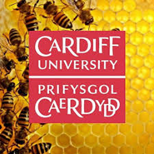
Pharmabees
Session 3

Your task is to create a video designing an experiment that studies either bees, pollination, bacteria, or another topic you learned about in the Pharmabees sessions.
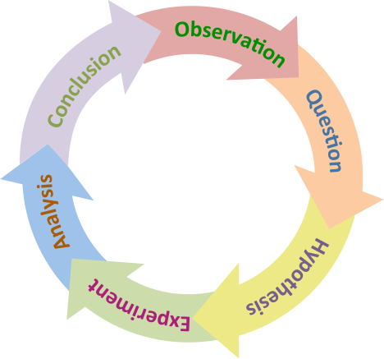

Please create a video recording a science experiment that your class designs using the scientific method. Please include the scientific process, preforming the experiment, your results, and what you learned. After you create your video, please send it to the Pharmabees team. We will be showing your videos when you visit Cardiff University. One of the videos will win a prize! You can email the videos to: Pharmabees@cardiff.ac.uk
Things to Think About:
Remember, a hypothesis is not necessarily the right explanation. Instead, it's a possible explanation that we can test to see if it is likely correct, or if we need to make a new hypothesis. It is ok if you prove your hypothesis wrong, that is part of science! Be sure to reflect on your results, then use them to guide your next steps.
Resources:
https://www.khanacademy.org/science/high-school-biology/hs-biology-foundations/hs-biology-and-the-scientific-method/a/the-science-of-biology
https://www.youtube.com/watch?v=uMAXaRbDNsM&t=6s

